BJD_TDB Converted Plug-in
The plug-in converts loaded observations to the HJD_{TDB} time scale. It recalculates the timestamps for both JD and HJD observations using the appropriate conversion algorithms.
The plug-in uses a local Python-based microservice. Please see the Appendix for information on how to install and configure it.To install the BJD_TDB Converter plug-in, go to the Tools menu in VStar and select Plug-in Manager. Scroll through the list of available plug-ins, select BJD_TDB Converter, and click the Install button. After installation, restart VStar.
As an example, load PMAK V5 data in the Johnson V filter for JD between 2458037 and 2458670: go to the File menu, select New Star from AAVSO Database, enter 'PMAK V5' in the Star field, and set Minimum JD to 2458037 and Maximum JD to 2458670. Ensure that the 'Johnson V' checkbox is selected and all others are unchecked, then click OK.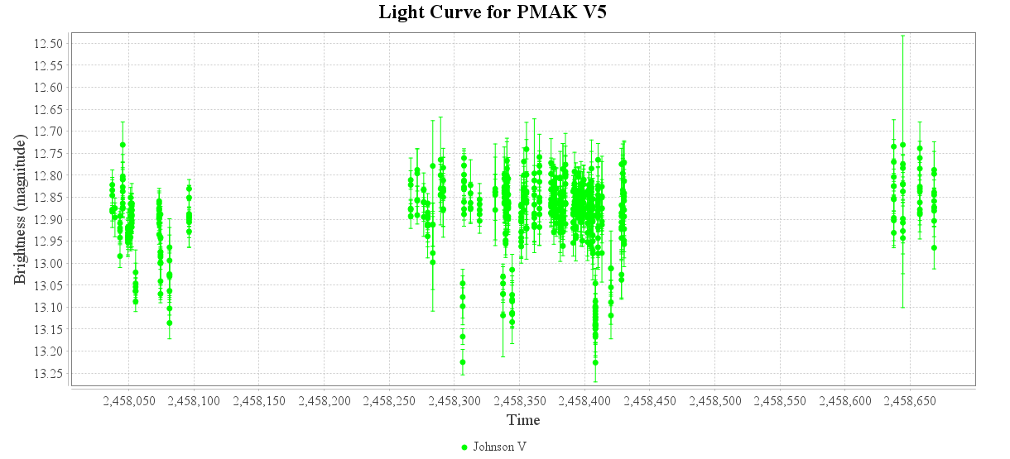
After loading the light curve, you can select a point and use the View -> Observation Details menu command to verify that the observations are in the JD time scale:
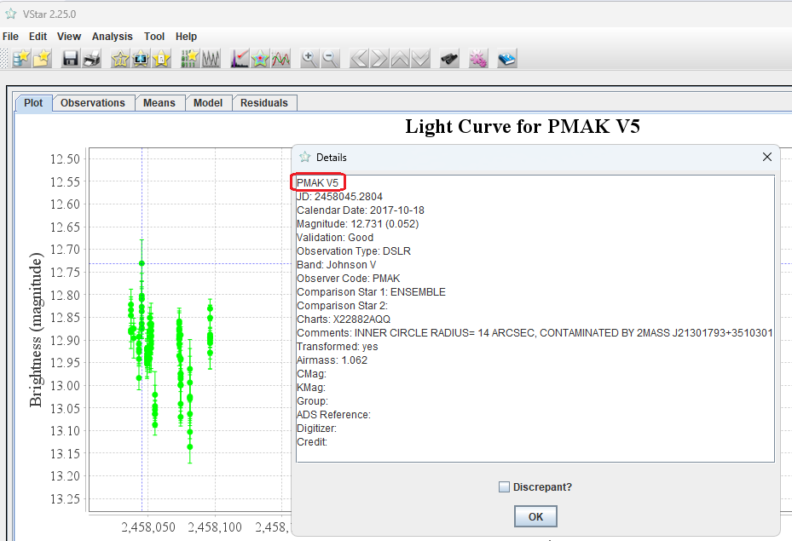
To convert the observation times to HJD_{TDB}, use the Tools -> BJD_TDB Converter command. The following dialog will appear:
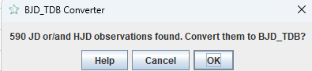
Click OK. After a brief delay, an information dialog will appear:
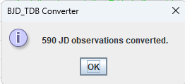
Use View->Observation Details again. You should see that the observations are now in the BJD_{TDB} time scale:
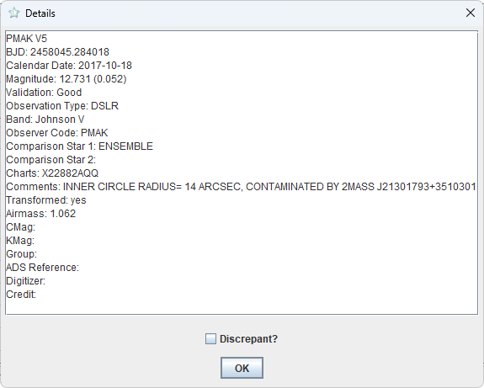

Appendix. Installing the Local Microservice
Prerequisites: Install Python 3.11 or higher. Then, install AstroPy and Flask packages. This can be done with the pip utils:
>pip install astropy
>pip install flask
The Python microservice ‘astro_time_convert.py’ is located in the ‘PyMicroService’ subfolder within the ‘vstar’ folder. Run it with the command:
>python astro_time_convert.py
Once the microservice launches successfully, you should see something like the following:
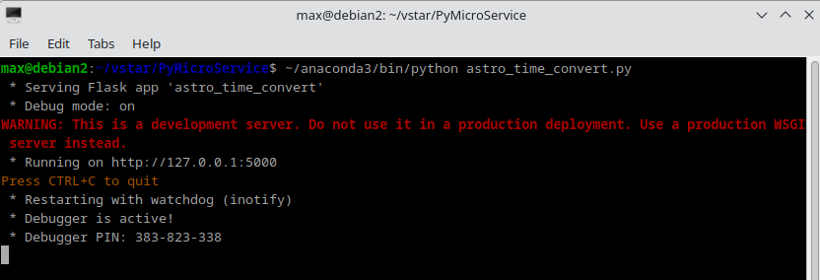
You may ignore the warning; it simply means that you are running a single-threaded internal Flask web server, which is perfectly sufficient for our needs.
To test the microservice, run VStar, load some data (for example, V405 Dra, all times, Johnson V). Invoke the [Tools] -> [BJD_TDB Converter] command and press OK.
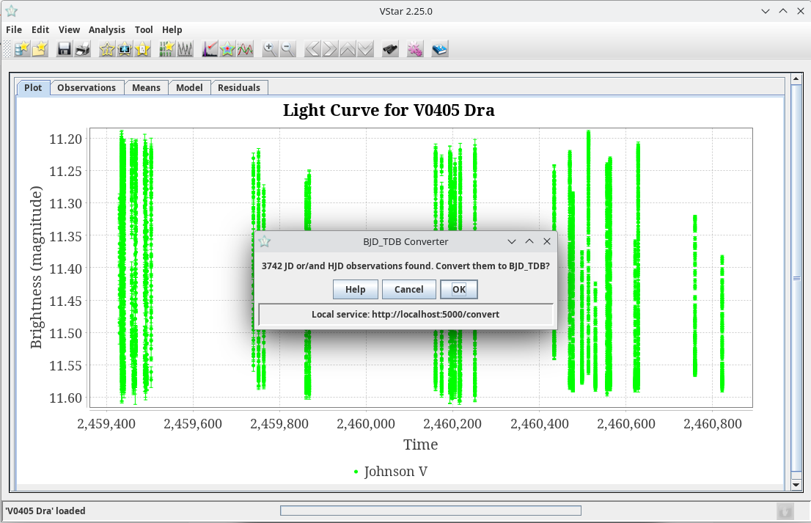
In a few seconds, you should see the following message (number of observations may differ):
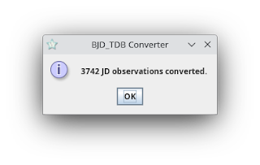

Maksym Pyatnytskyy
Rev B, 2026-06-07
Rev A, 2025-06-19

You can find a comprehensive discussion of the various astronomical time scales and the significance of HJDTDB here: https://ui.adsabs.harvard.edu/abs/2010PASP..122..935E/abstract

